Subject Area: Music
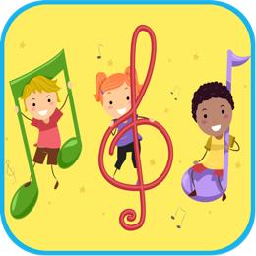
App Title: Music Theory For Children
App Price: $9.99
Languages: English

Rationale: This app is designed with the young learner in mind. Students will be introduced to the basic theory of music and with 173 Music Theory Video Lessons to choose from, student have endless opportunities to continue musical learning through a variety of instruments and sounds. Video demonstrations modeling and guiding instruction are provided for students, granting students opportunities to practice while they are learning.

New York State Learning Standards for the Arts
- Standard Strand: Knowing and Using Arts Materials and Resources
- Grade: Elementary
- Topic: Music Standard 2
- Item number and statement:

a. use classroom and nontraditional instruments in performing and creating music

b. construct instruments out of material not commonly used for musical instruments

c. use current technology to manipulate sound

Ontario Curriculum Expectations
- Standard Strand: The Arts Standards 1-8
- Grade: 1
- Topic: Music
- Item number and statement: In Grade 1, they make connections with the role of music in their lives, sing and play in unison, create simple accompaniments, and experiment with found sounds and instruments.

